

DEPARTMENT OF COMPUTER SCIENCES

PROGRAMMING FOR AI
AI-212

LAB MANUALS

INSTRUCTOR 2023-BS-AI-020
MR SAMRAIZ MISHAL NADEEM

CONTENTS

Lab 01…………………………………………..………………………………………….3
Lab 02…………………………………...…………………………………..……………..8
Lab 03…………...………………………………………………………………………..13
Lab 04………………………….…………………………………………………………18
Lab 05……………………..……………………………………………………...………23
Lab 06……………………..……………………………………………………………...28
Lab 07…………………….………………………………………………………….…...33
Lab 08………...……………………………………………………………………..……38
Lab 09………..………………………………………………………………..………….43
Lab 10………..………………………………………………………..………………….48
Lab 11……………...………………………………………………..……………………53
Lab 12…………………...………………………………………………….…………….58

Lab 1

Q1. Banking Transaction Validator with PIN
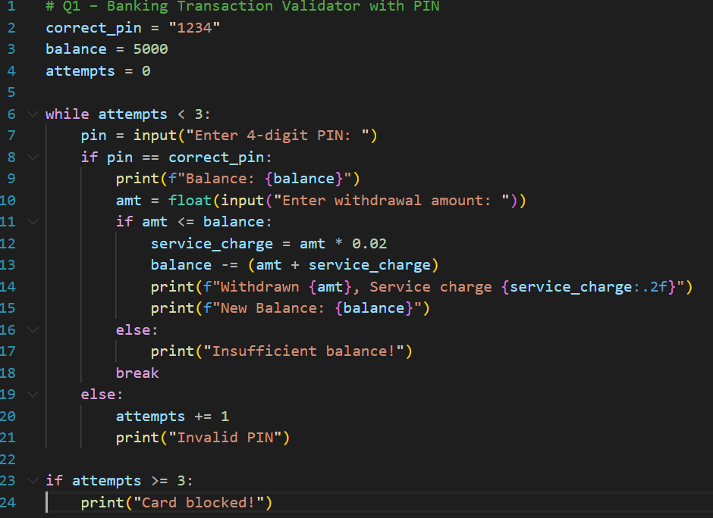
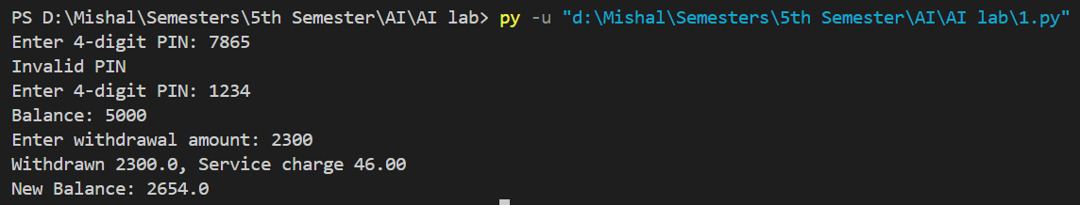

Q2. Grocery Store Inventory System
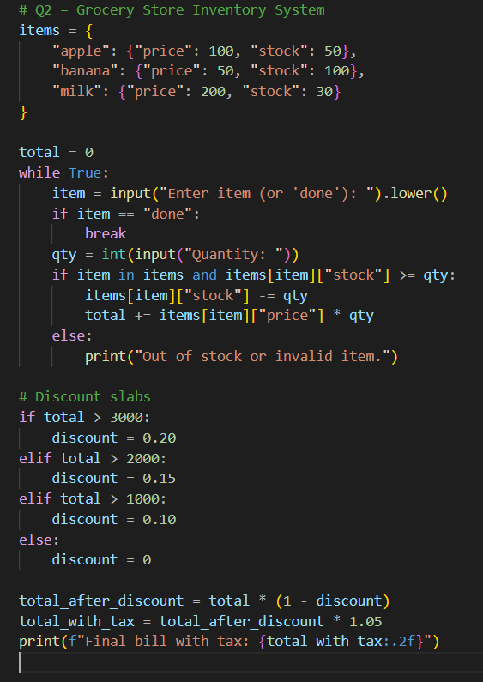
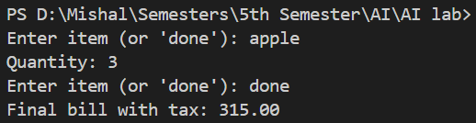
Q3. Student Grading with Subject Weightage
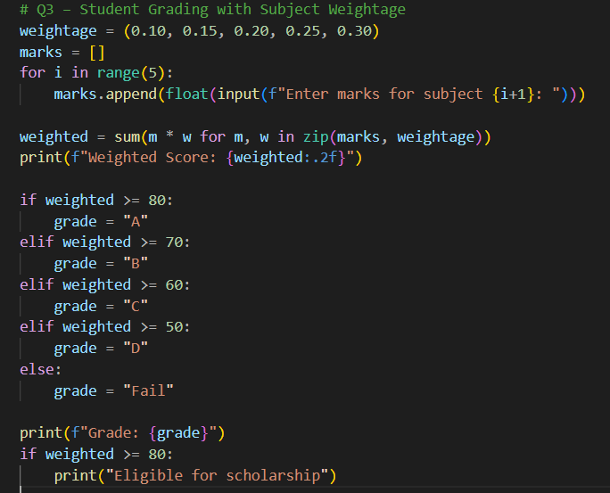
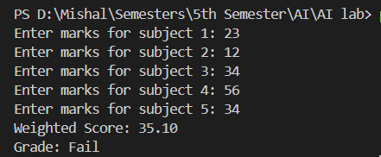

Q4. BMI + Health Recommendation
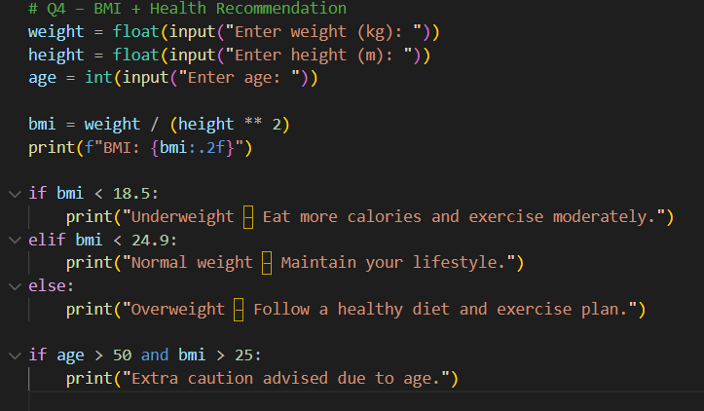
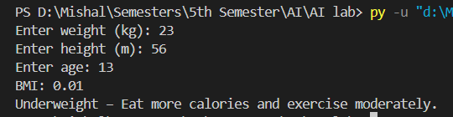

Q5. Telecom Prepaid Recharge System
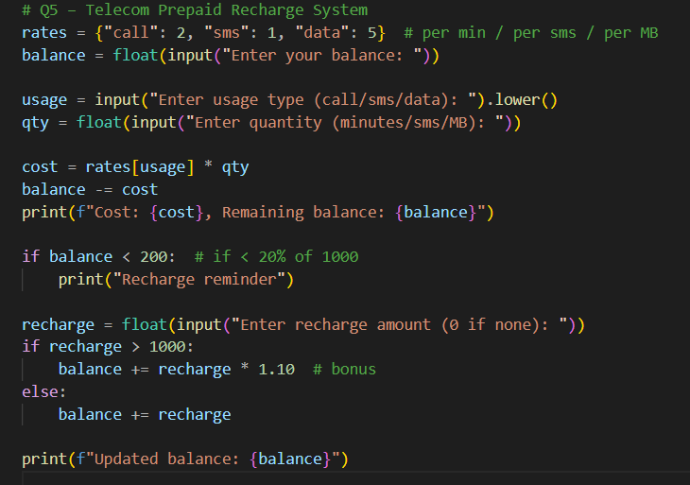
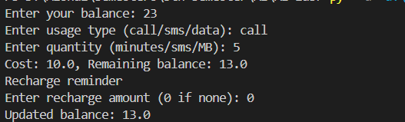

Lab 2

Q6. E-Commerce Discount Engine with Membership Levels
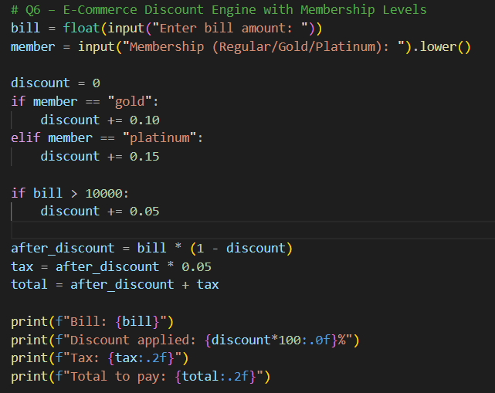
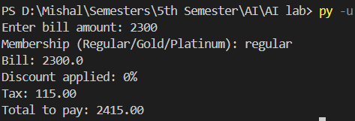
Q7. Hospital Emergency Unit with Multi-Condition Triage
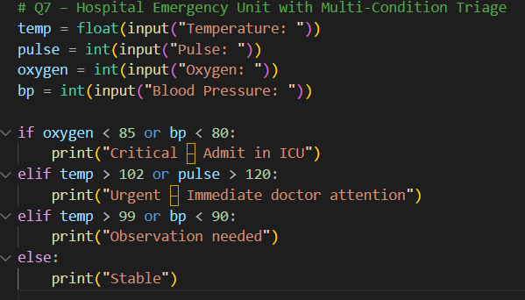
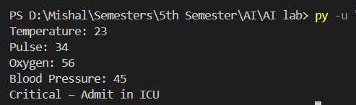

Q8. Online Examination Grader with Negative Marking
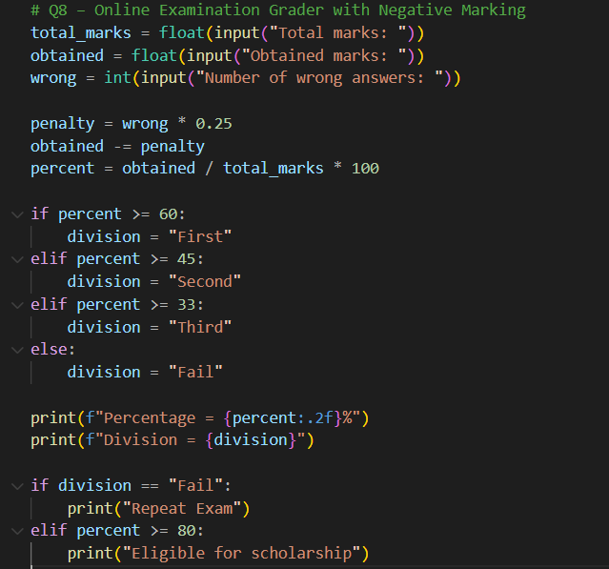
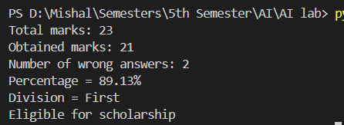
Q9. Movie Ticket Booking with Age & Timing Policy
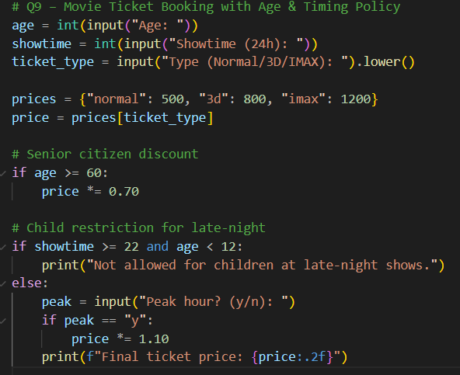
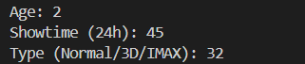

Q10. Weather-based Outfit + Travel Suggestion
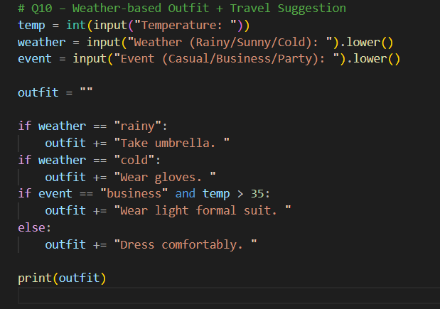
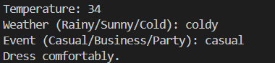

Lab 3

Q11. ATM Withdrawal with Note Counting + Receipt
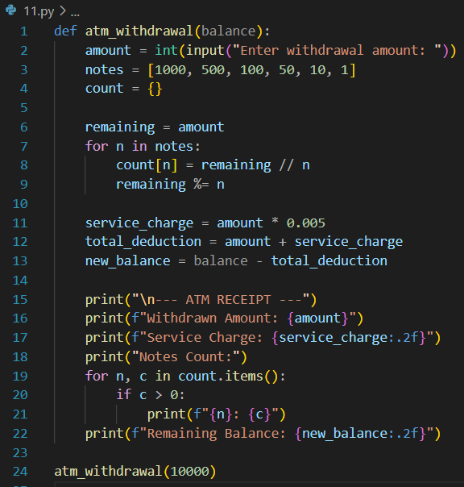
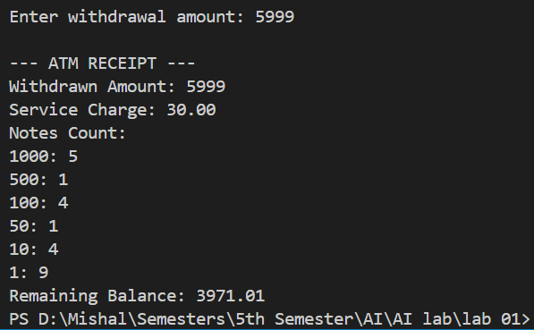
Q12. Library Fine Calculator with Membership Levels
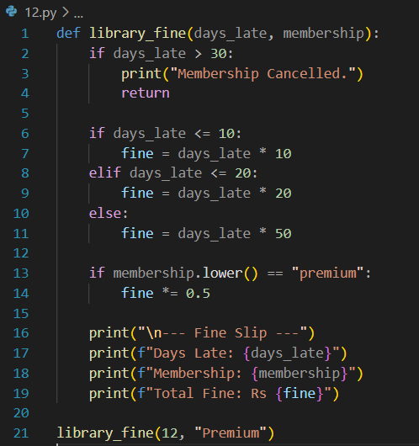
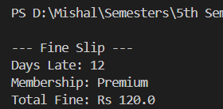

Q13. Sales Analysis Dashboard
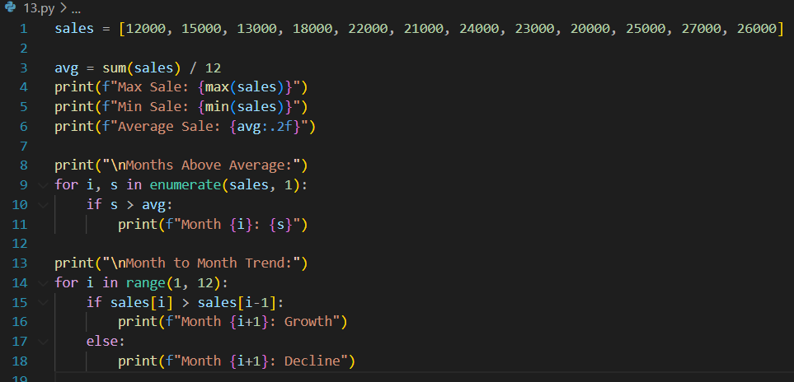
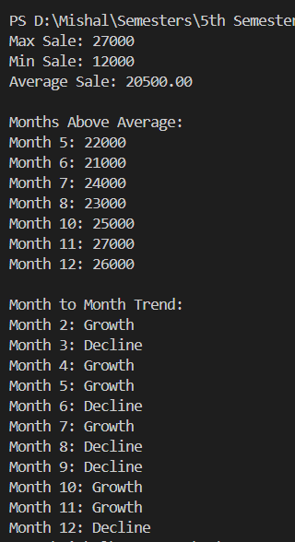
Q14. Multiplication Puzzle with Random Blanks
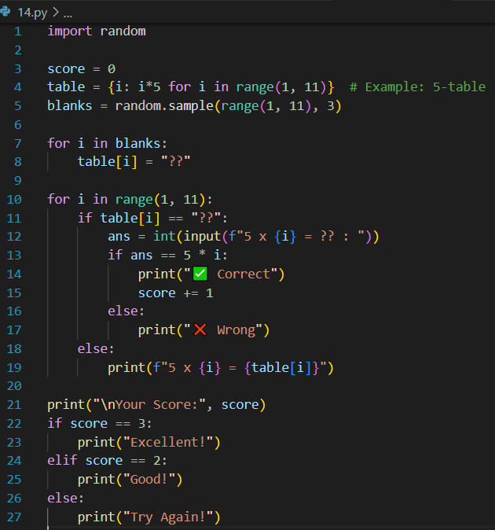
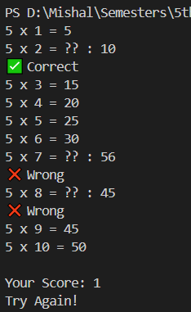
Q15. Password Strength + Re-entry Attempts
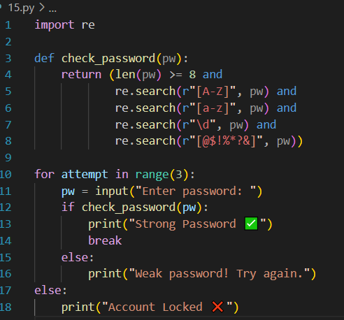
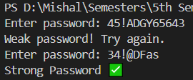

Lab 4

Q16. Electricity Bill with Slabs & Penalty
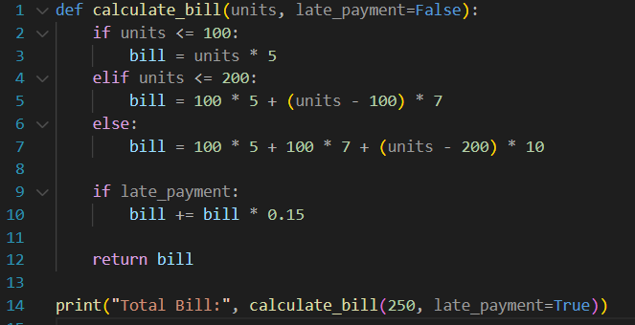
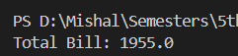

Q17. Cricket Match Predictor with Multiple Conditions
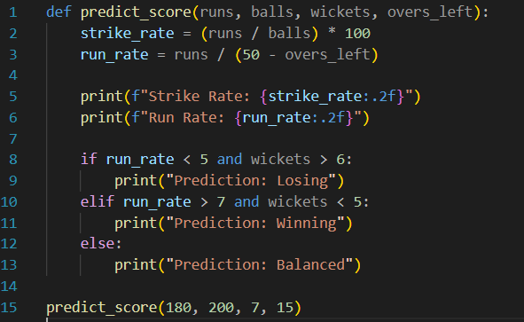
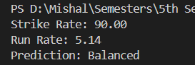

Q18. Hotel Booking with Tax & Discount
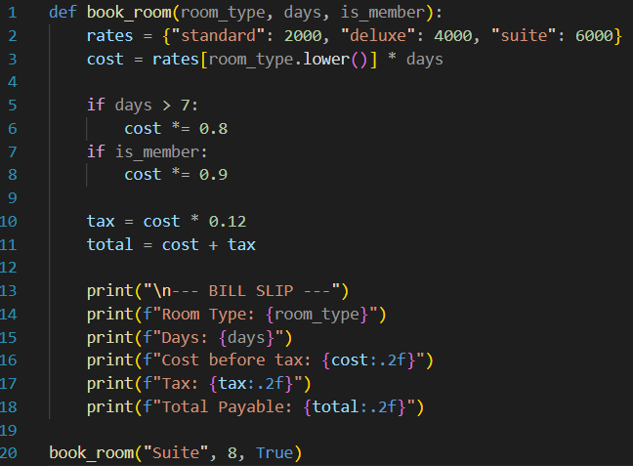
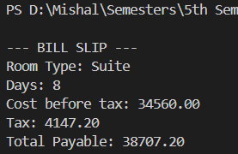
Q19. Flight Fare Calculator with International Tax
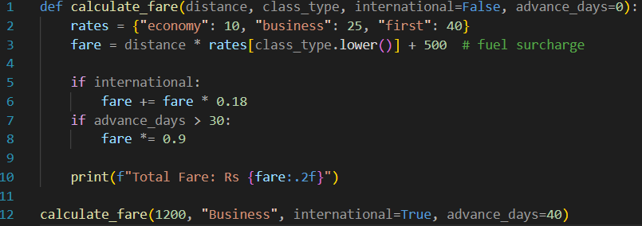
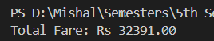

Q20. Smart Vending Machine with Wallet System
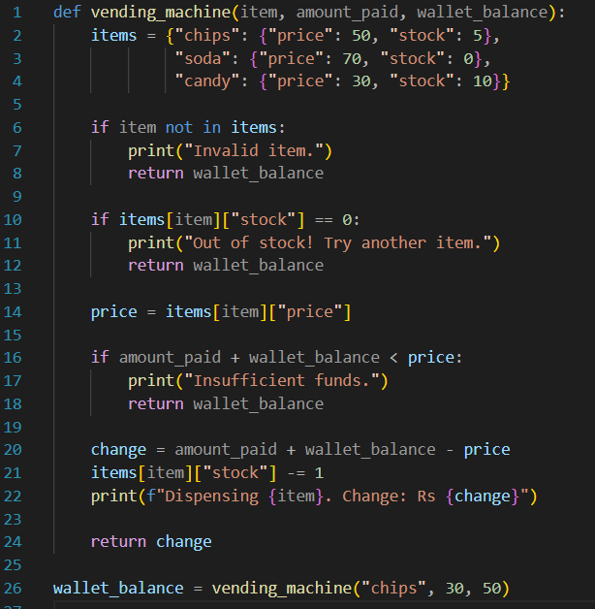
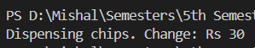
Lab 5

Q1. Bank Account Management System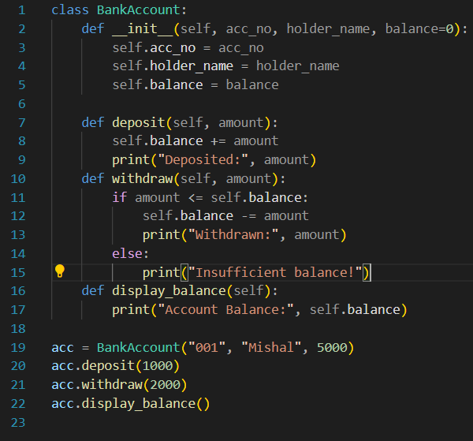
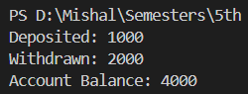
Q2. Library Book Management System
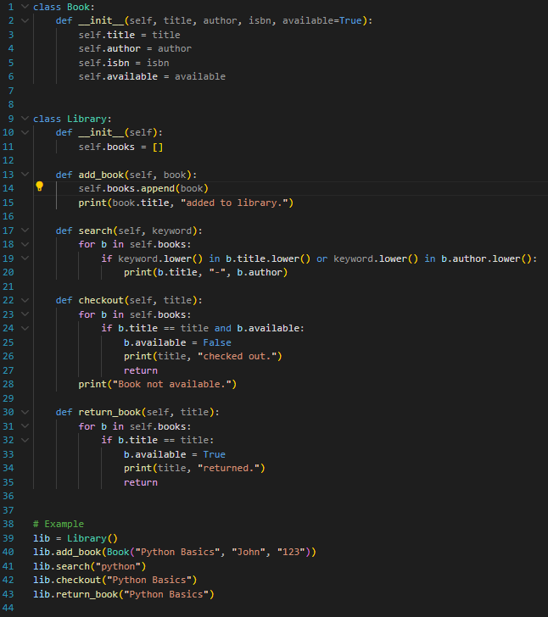
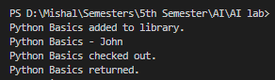
Q3. Student Grading System
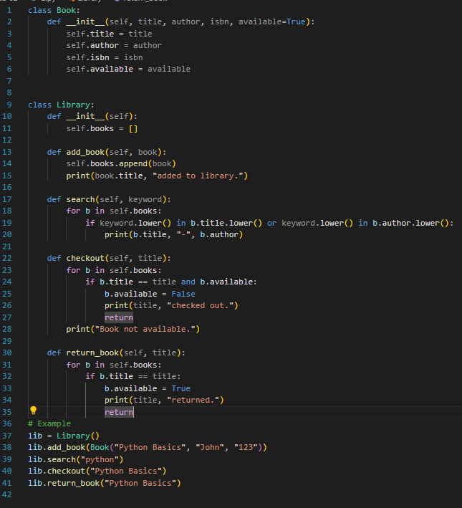
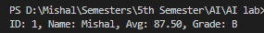
Q4. Food Ordering & Billing System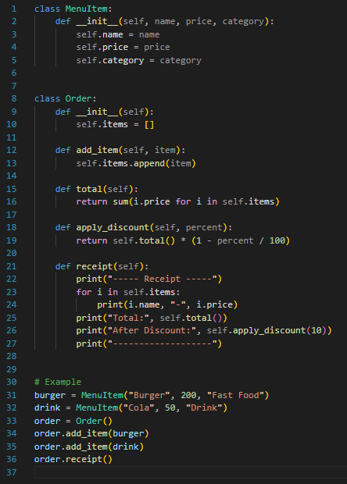
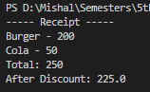
Q5. Vehicle Rental System
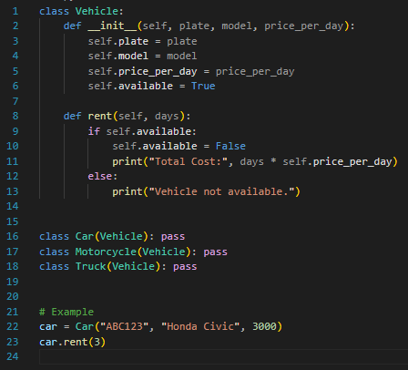

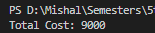

Lab 6

Q6. Employee Payroll Management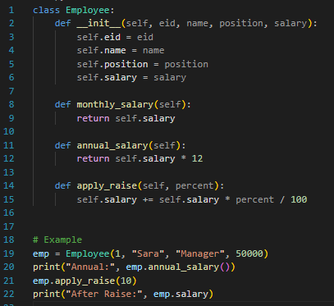
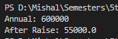
Q7. Shopping Cart & Inventory System
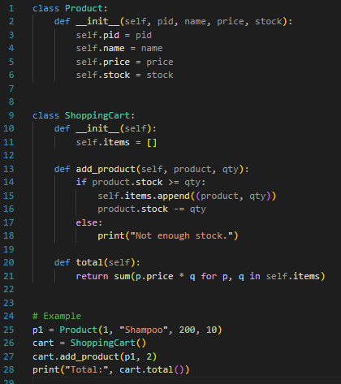
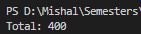
Q8. Patient Appointment Management
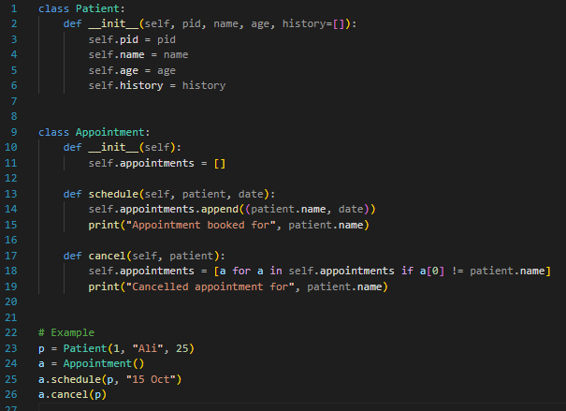
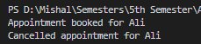

Q9. Social Media User System
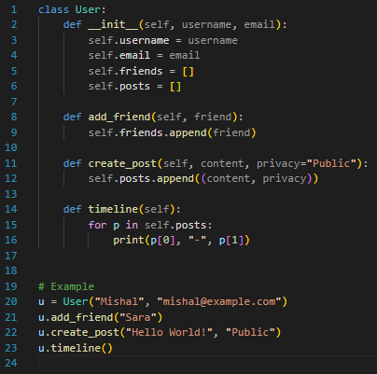
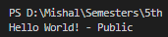

Q10. Hotel Room Booking System
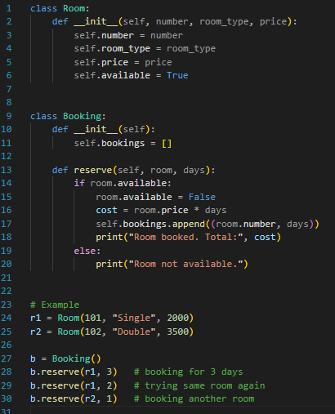
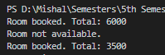
Lab 7

Q11. Course Registration System
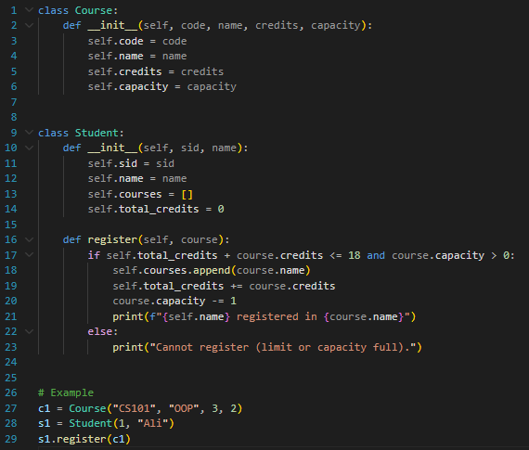
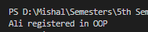
Q12. Inventory Stock Management System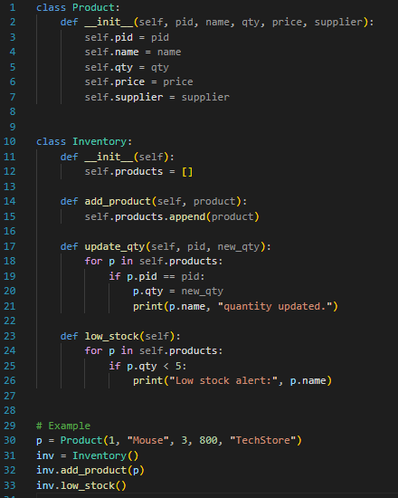
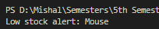
Q13. Movie Ticket Booking System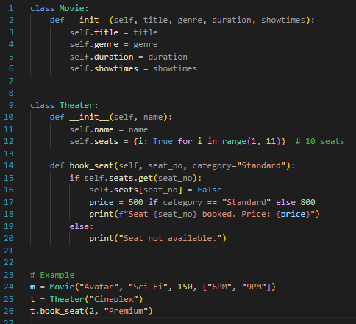
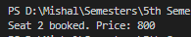

Q14. Gym Membership & Training System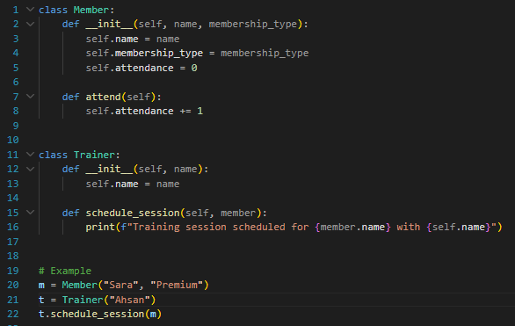
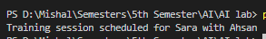

Q15. Advanced Bank Account System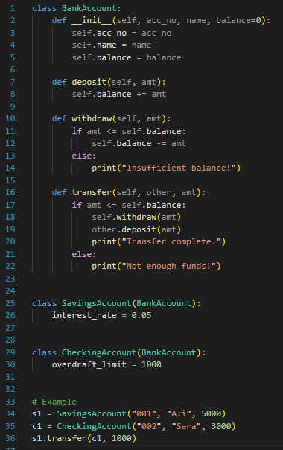
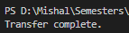
Lab 8

Q16. Pizza Ordering System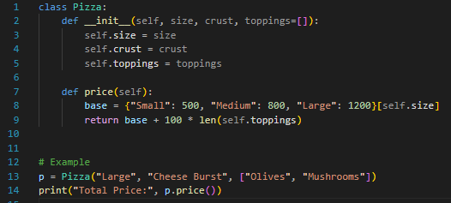
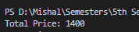

Q17. Car Manufacturing System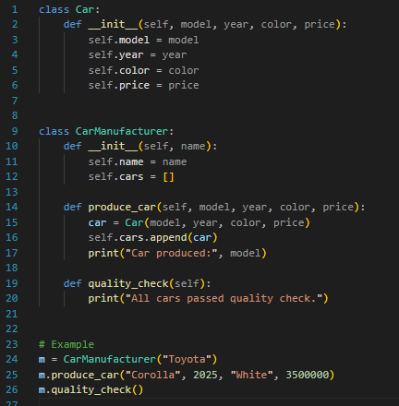
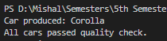

Q18. Classroom Management System
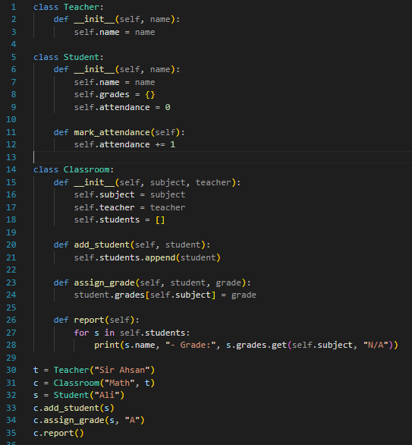
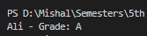
Q19. Flight Reservation System
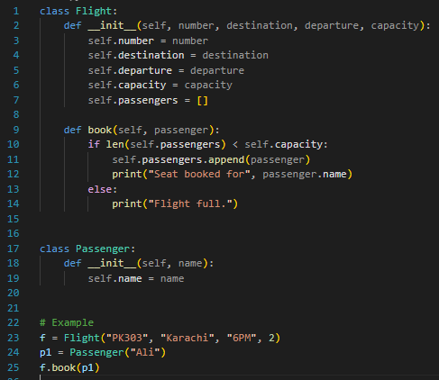
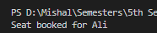

Q20. Smart Home Automation System
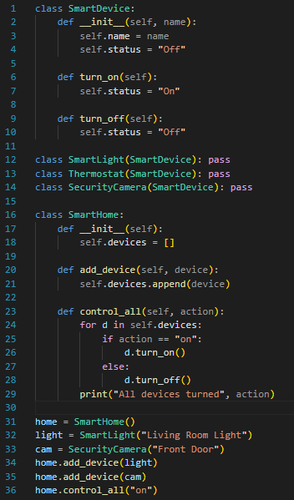
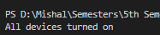
Lab 9

Q1. A weather station records temperatures (°C) for 7 days:
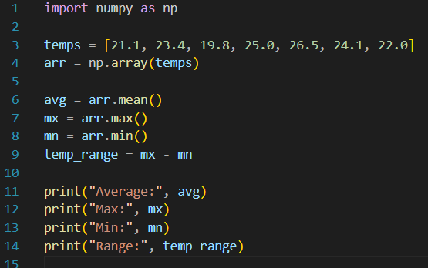
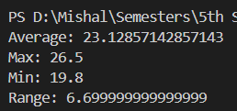

Q2. A fruit store records daily sales of apples for 4 weeks:
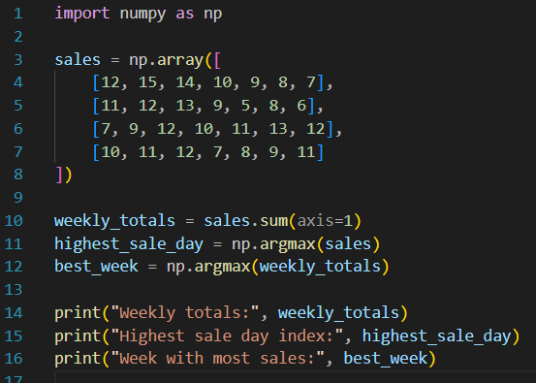
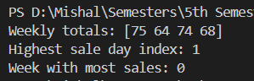
Q3. Students received marks in a test:
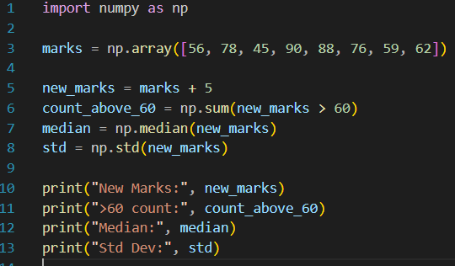
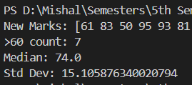

Q4. A smartwatch stores daily step-counts for a user for 30 days.
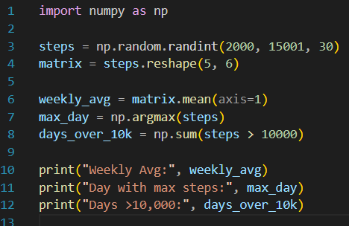
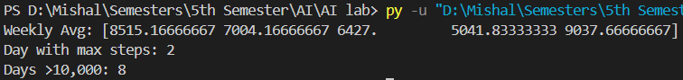

Q5. Heart rate readings (in BPM) for 10 patients recorded 4 times per day:
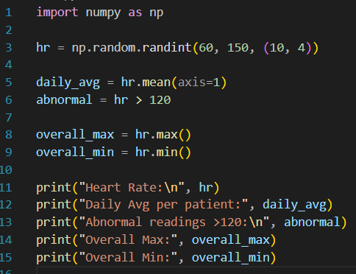
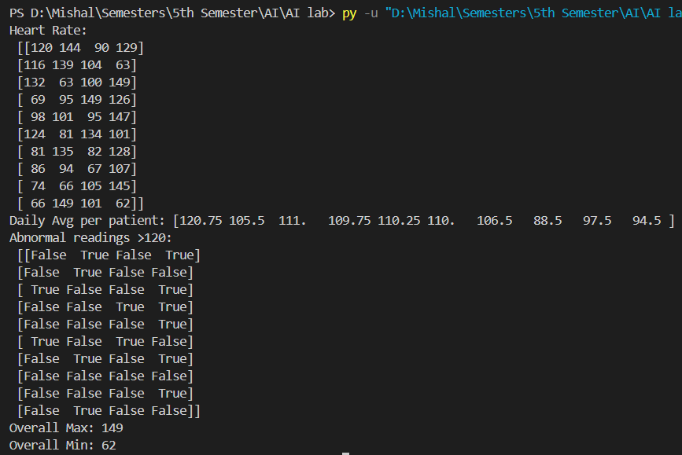
Lab 10

Q6. Two branches of a store record monthly sales (in thousands):
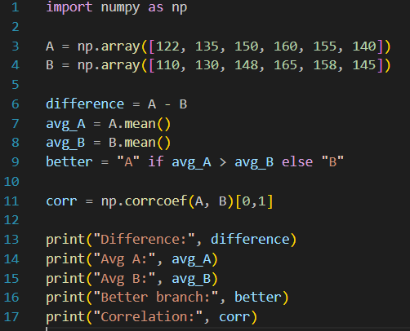
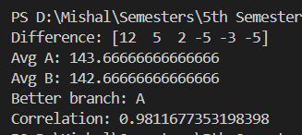
Q7. Given a 4×4 grayscale image:
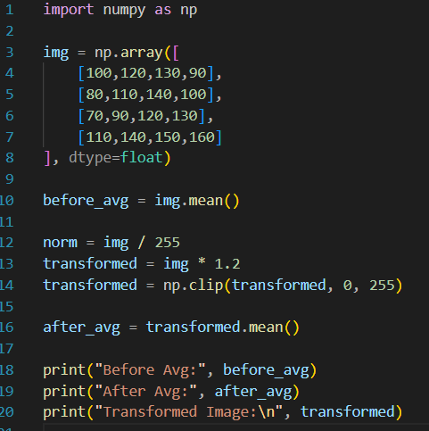
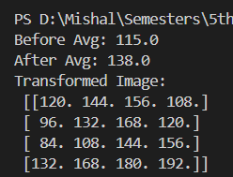
Q8. Dataset contains 100 samples with 4 features each.
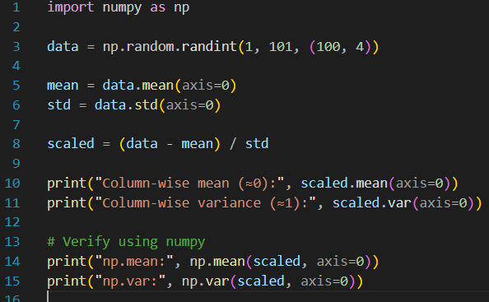
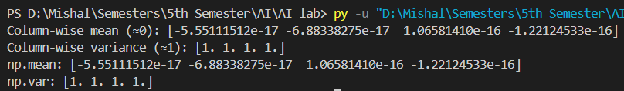

Q9. Simulate traffic density (cars per minute) recorded by 6 sensors over 24 hours.
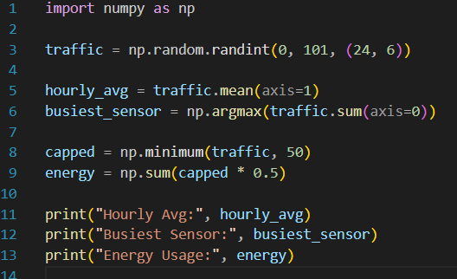
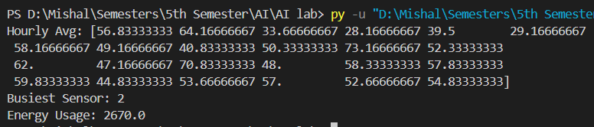

Q10. You are simulating forces in a mechanical system.
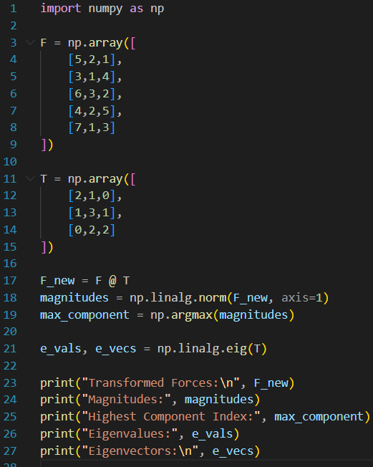
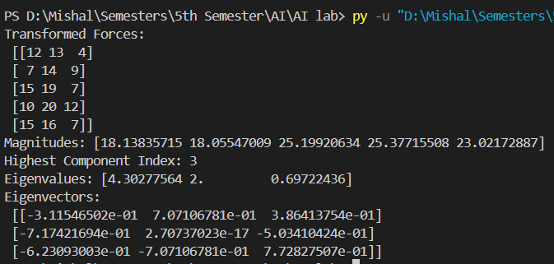
Lab 11

Q1. Patient Stay Analysis (Healthcare)
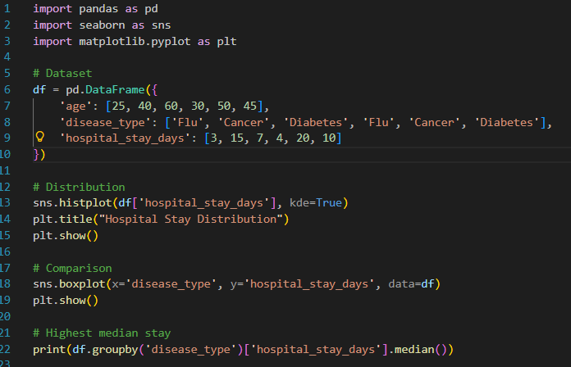
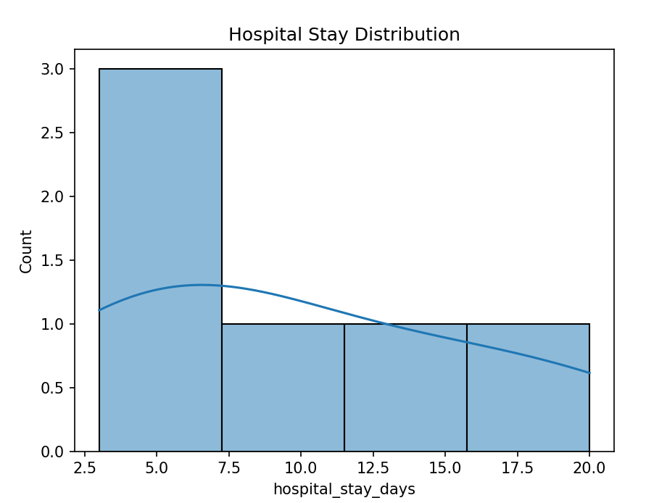
Q2. Sales Distribution Comparison (Business)
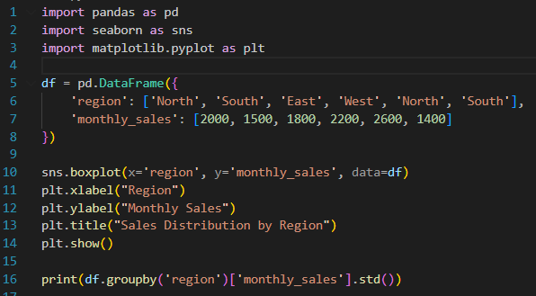
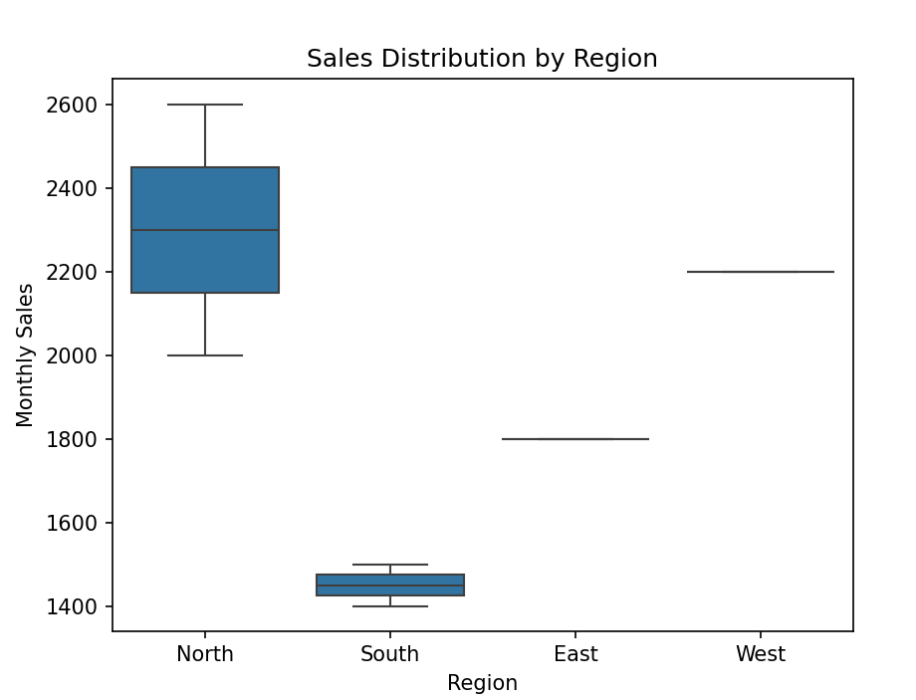
Q3. Student Performance Correlation (Education)
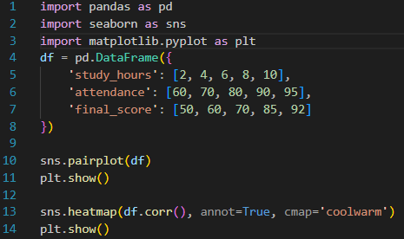
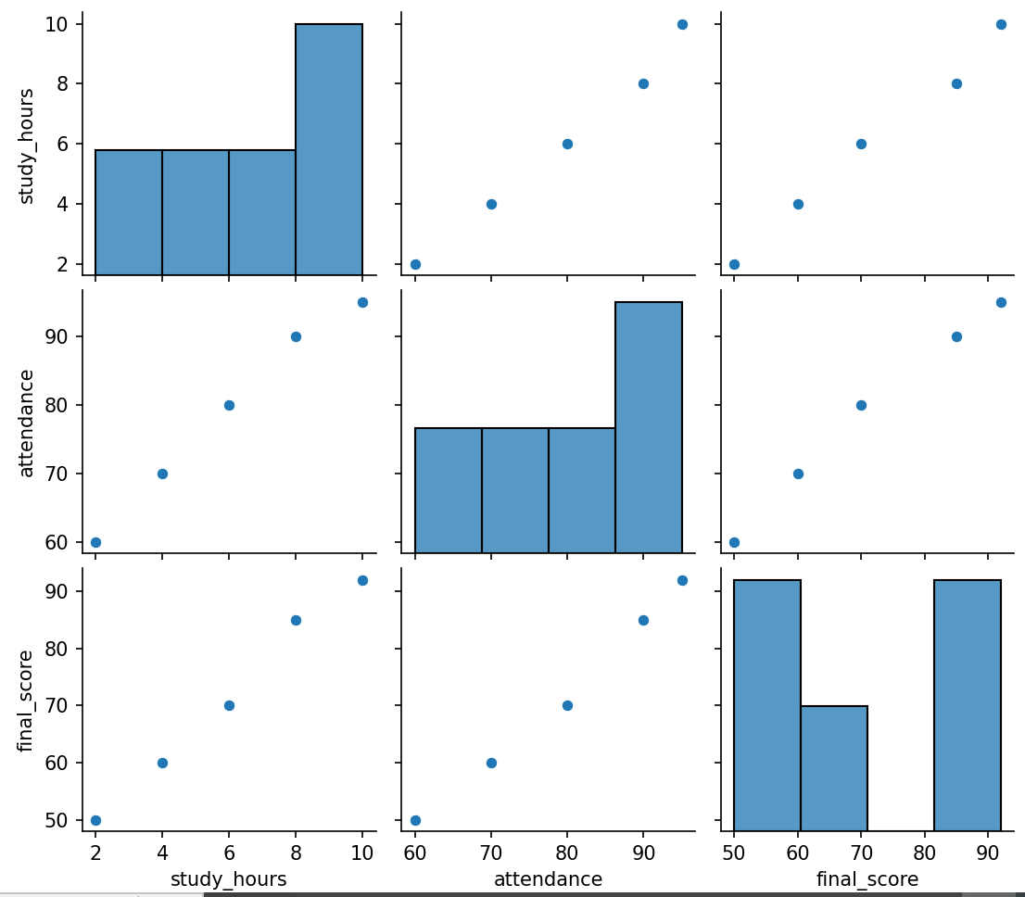
Q4. Customer Segmentation Visualization
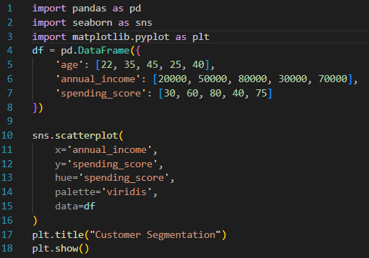
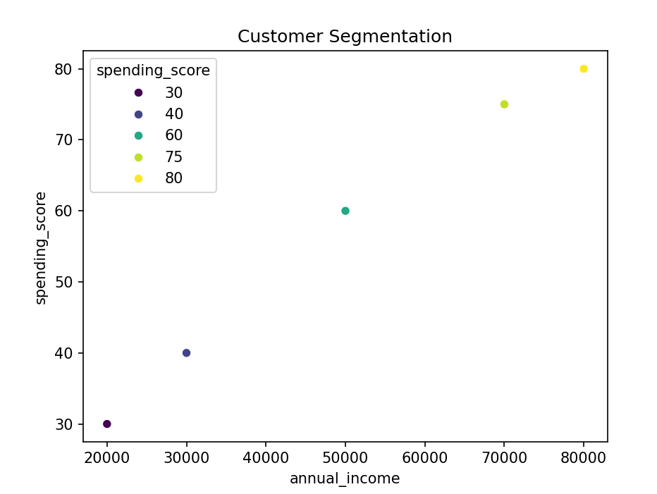
Q5. Model Result Visualization (Confusion Matrix)
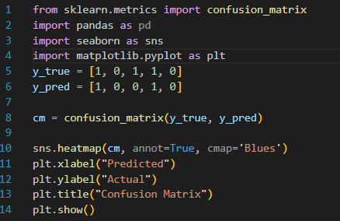
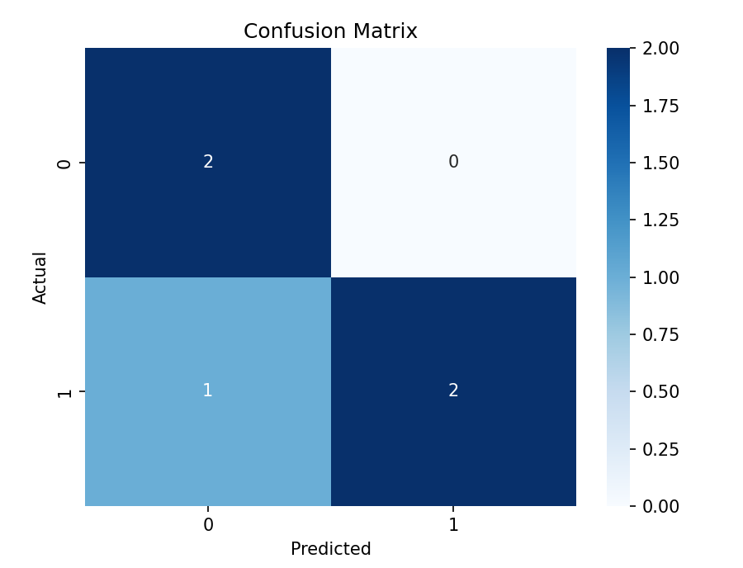
Lab 12

Q6. Telecom Customer Churn Prediction
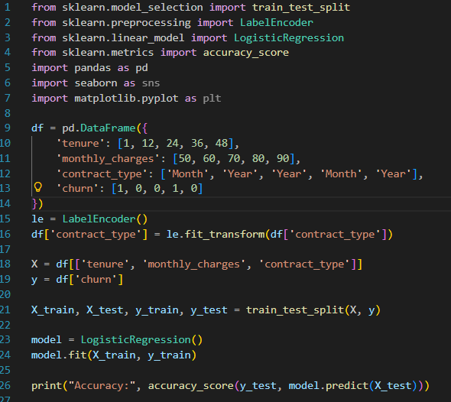
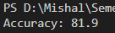
Q7. House Price Prediction
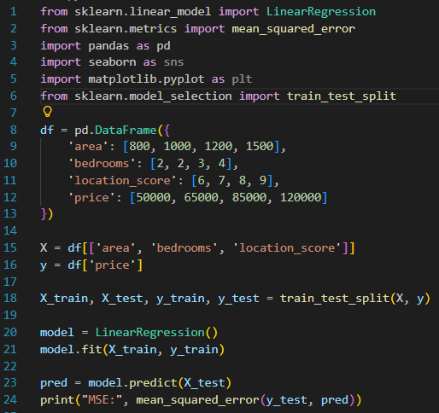
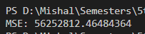

Q8. Disease Classification System
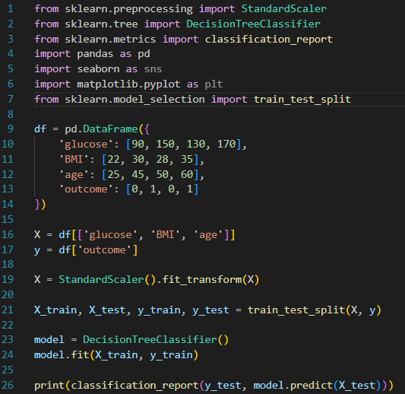
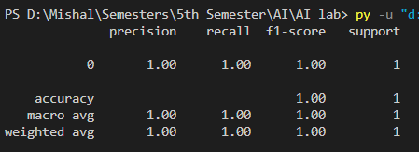
Q9. Email Spam Detection
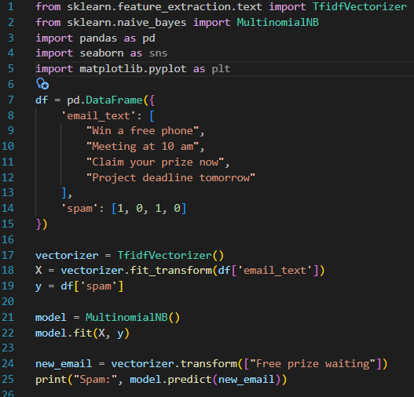
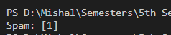

Q10. Student Risk Prediction
